Hypotheses wave 1 short answers

H1

All policy attributes (policy costs (associated tax increase), time of policy implementation, resulting energy independence and estimated CO2 reduction) significantly predict policy decisions.

After model comparison, a model with random slopes instead of random intercept was chosen since the coefficients remain almost identical and Conditional R2 significantly improves (R2 = .788 versus R2 = .484). Furthermore, random slopes are needed to analyte H1c.

The model chose

The model with random slopes supports Hypothesis 1 (as do all alternative models including the pre-registered one, estimates only minimally change and the order of importance remains the same).

All four attributes: associated tax increase, time of policy implementation, resulting energy independence and estimated CO2 reduction significantly predicted policy decisions.

Controlling for demographics does not change these results. An age effect can be observed with differences between the highest and youngest age groups, with the higher age group being less likely to accept policy decisions than the younger ones. The more people identified with “right” versus “left” politics the less likely they were to accept policies. And the more they trusted in the government the more likely they were to accept policies

|  |  |  |  |
| --- | --- | --- | --- |
|  | **decision** | | |
| *Predictors* | *Odds Ratios* | *CI* | *p* |
| (Intercept) | 4.26 | 3.64 – 4.99 | **<0.001** |
| co2-30% CO2 | 1.71 | 1.56 – 1.87 | **<0.001** |
| tax (1% vs 6%): +6% | 0.04 | 0.04 – 0.05 | **<0.001** |
| energyindependence (10% vs 20%): +20% | 1.35 | 1.24 – 1.47 | **<0.001** |
| implementation (in 1 vs 7 years): in 7 Jahren | 0.24 | 0.20 – 0.29 | **<0.001** |
| **Random Effects** | | | |
| σ2 | 3.29 | | |
| τ00 id | 5.66 | | |
| τ11 id.co2-30% CO2 | 0.57 | | |
| τ11 id.tax+6% | 9.66 | | |
| τ11 id.energieabhaengigkeit+20% | 0.21 | | |
| τ11 id.zeitpunktin 7 Jahren | 7.79 | | |
| ρ01 | -0.03 | | |
|  | -0.30 | | |
|  | -0.08 | | |
|  | -0.33 | | |
| ICC | 0.74 | | |
| N id | 1628 | | |
| Observations | 26048 | | |
| Marginal R2 / Conditional R2 | 0.195 / 0.788 | | |

Marginal R2 / Conditional R2 0.195 / 0.788

H1a

The policy attributes costs and CO2 reduction potential will receive most relative importance in participants’ policy acceptance decisions

As can be taken from H1: Tax has the highest OR / coefficient followed by time of policy implementation and only then CO2 reduction potential.

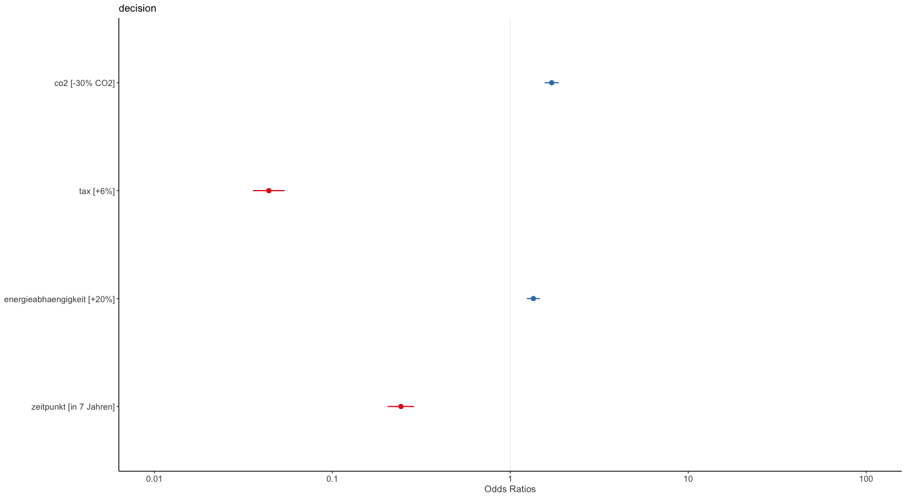

H1b

Climate change concern will significantly predict the number of renewable energy policy choices in that higher climate change concern scores are associated with a higher likelihood to accept renewable energy policies. This effect is assumed to be especially pronounced for policies that will be implemented in the near future (implementation 1 year) compared to policies that will be implemented in the far future (implementation in 7 years).

Results support H1b. Climate change concern was significantly positively associated with support of RE policies. Furthermore, an interaction between climate change concern and time of implementation emerged such that those with high climate change concern were much more likely to accept immediate policies versus distant policies, whereas the opposite pattern could be seen for those with very low cc concern who were more likely to accept distant policies.

Controlling for demograhics reveals the same picture.

|  |  |  |  |
| --- | --- | --- | --- |
|  | **decision** | | |
| *Predictors* | *Odds Ratios* | *CI* | *p* |
| (Intercept) | 4.19 | 3.59 – 4.89 | **<0.001** |
| co2-30% CO2 | 1.69 | 1.54 – 1.85 | **<0.001** |
| tax (1% vs 6%): +6% | 0.04 | 0.04 – 0.05 | **<0.001** |
| energyindependence (10% vs 20%): +20% | 1.39 | 1.28 – 1.52 | **<0.001** |
| implementation (in 1 vs 7 years): in 7 Jahren | 0.24 | 0.20 – 0.28 | **<0.001** |
| concern.scaled | 2.41 | 2.18 – 2.67 | **<0.001** |
| zeitpunktin 7 Jahren:concern.scaled | 0.46 | 0.40 – 0.52 | **<0.001** |
| **Random Effects** | | | |
| σ2 | 3.29 | | |
| τ00 id | 5.25 | | |
| τ11 id.co2-30% CO2 | 0.59 | | |
| τ11 id.tax+6% | 9.74 | | |
| τ11 id.energieabhaengigkeit+20% | 0.19 | | |
| τ11 id.zeitpunktin 7 Jahren | 6.83 | | |
| ρ01 | -0.26 | | |
|  | -0.33 | | |
|  | -0.25 | | |
|  | -0.23 | | |
| ICC | 0.72 | | |
| N id | 1628 | | |
| Observations | 26048 | | |
| Marginal R2 / Conditional R2 | 0.239 / 0.788 | | |

*Caveat: climate concern is highly skewed, no transformation (log, log10, sqrt or square helped) –*

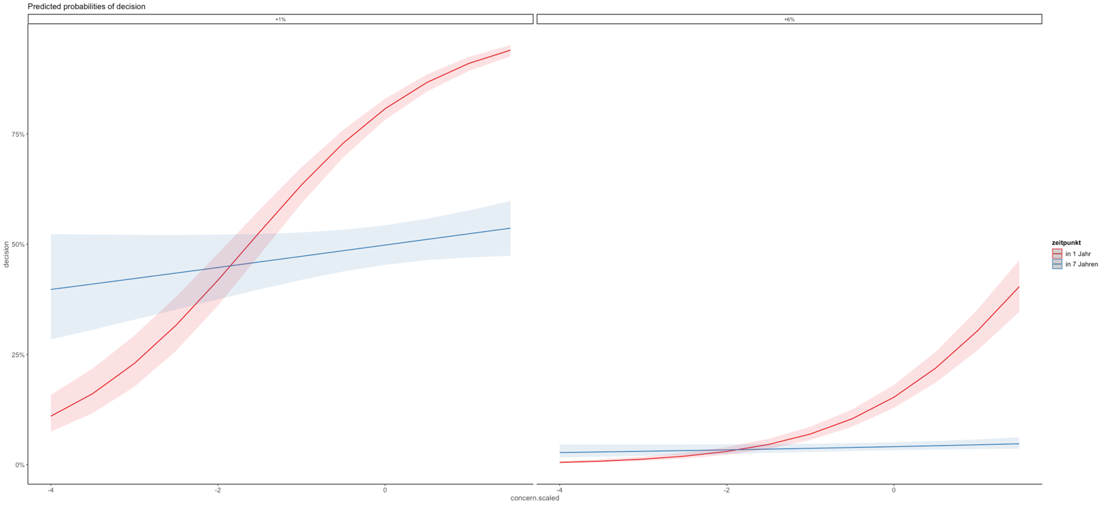

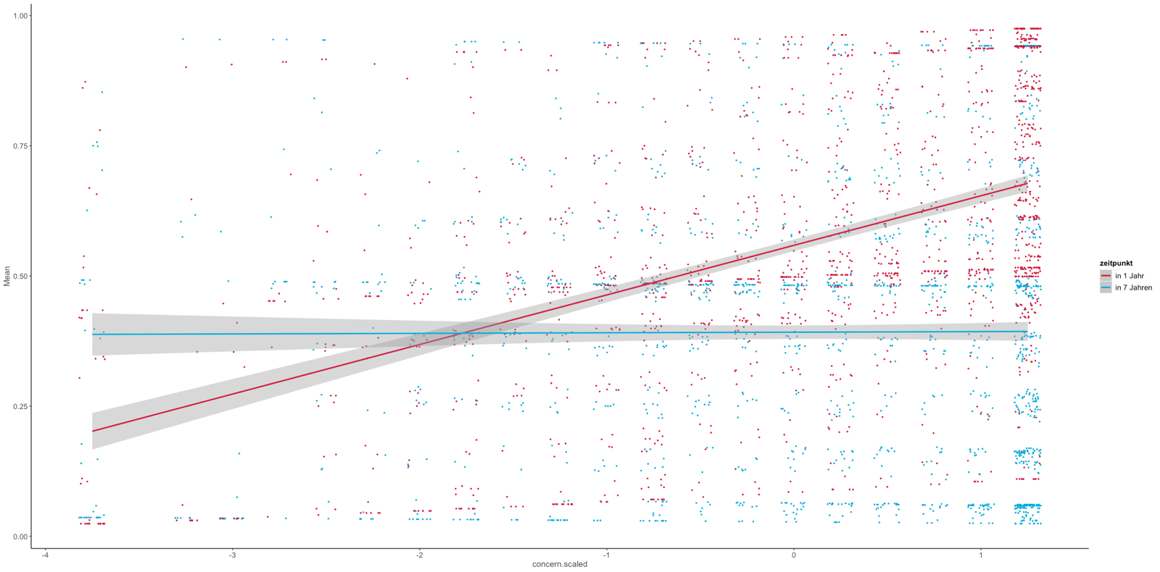

H1c

Climate change concern will significantly predict the importance participants assigned to the policy CO2 emission reduction potential in that higher climate change belief scores are associated with higher relative importance assigned to CO2 emission reduction potential.

Individual climate change concern predicted the individual importance placed on the Co2 reduction attribute such that higher concern was associated with a higher value for the CO2 coefficient.

With removing outliers (1,5*interquartile range) this associations stays significant and is slightly smaller (0.044 versus 0.0543)

Political orientation was negatively associated with importance placed on the CO2 attribute, such that those who identified with “right” politics had lower importance values.

|  |  |  |  |
| --- | --- | --- | --- |
|  | **CO2 attribute importance** | | |
| *Predictors* | *Estimates* | *CI* | *p* |
| (Intercept) | 0.570 | 0.469 – 0.670 | **<0.001** |
| climate change concern (scaled) | 0.054 | 0.039 – 0.070 | **<0.001** |
| gender: male | -0.005 | -0.040 – 0.029 | 0.768 |
| age30-39 | -0.015 | -0.072 – 0.042 | 0.610 |
| age40-49 | 0.004 | -0.053 – 0.061 | 0.885 |
| age50-59 | 0.036 | -0.020 – 0.093 | 0.202 |
| age60-80 | 0.013 | -0.040 – 0.066 | 0.634 |
| income: <1'500€ <3'100CHF | -0.049 | -0.102 – 0.004 | 0.070 |
| income: > 4'000€ >5'900 CHF | -0.001 | -0.049 – 0.047 | 0.972 |
| income: 2'500- 4'000€ <4'300- 5'899CHF | -0.033 | -0.080 – 0.015 | 0.175 |
| countrySwitzerland | 0.009 | -0.025 – 0.044 | 0.596 |
| education: obligatory school | 0.018 | -0.038 – 0.075 | 0.520 |
| education: middle school | 0.042 | -0.019 – 0.102 | 0.175 |
| education: degree | 0.065 | 0.006 – 0.124 | **0.031** |
| politicalorientation_1 | -0.021 | -0.031 – -0.012 | **<0.001** |
| trust.gov | 0.006 | -0.009 – 0.021 | 0.419 |
| Observations | 1628 | | |
| R2 / R2 adjusted | 0.082 / 0.073 | | |

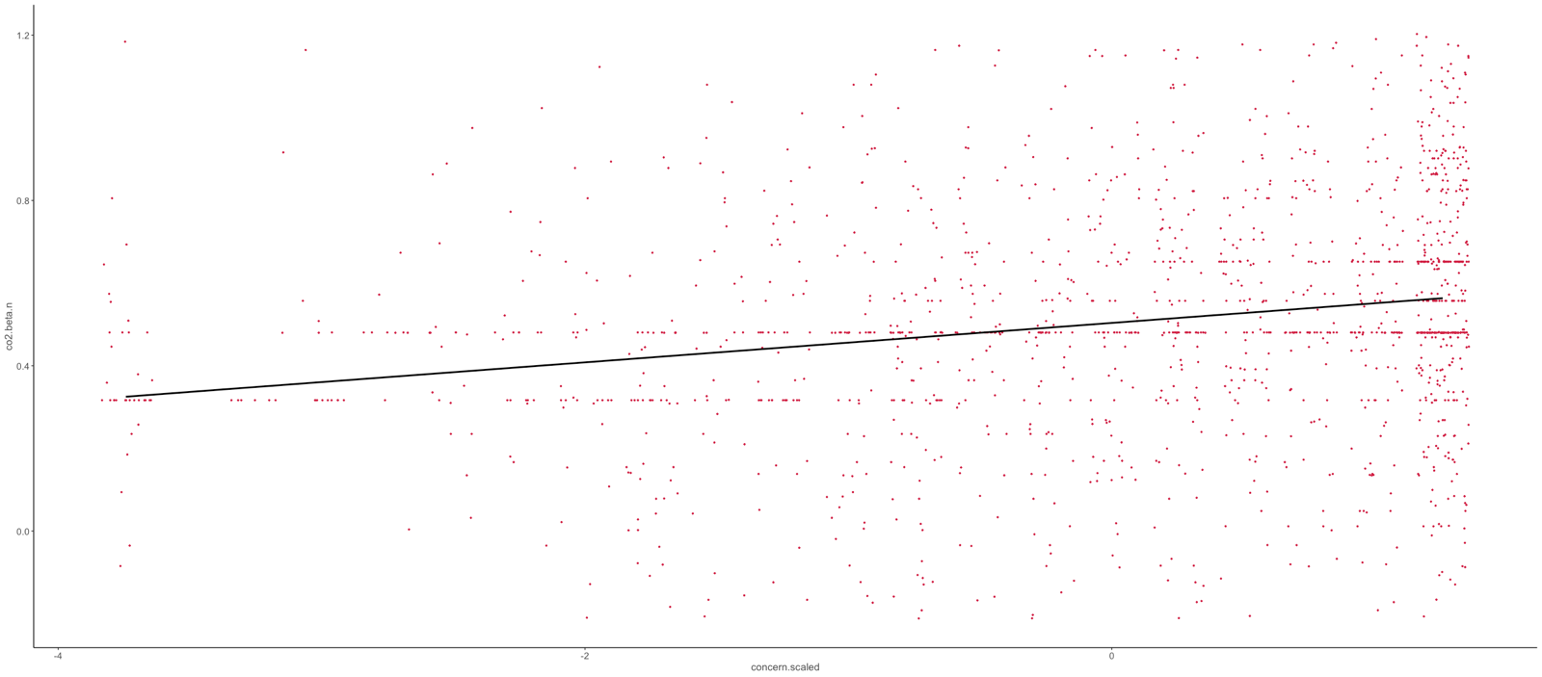

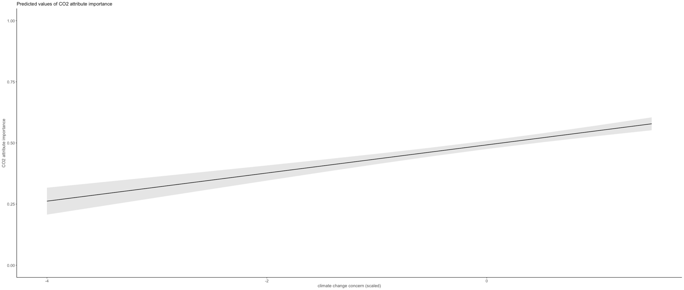

H2

The complexity of cognitive representations of energy behaviors will be captured with two dimensions, reflecting impact direction (negative vs. positive impact for the climate) and impact strength (low vs. high impact on the climate), with impact direction being the most dominant dimension

Confirmatory individual difference scaling shows that the judgments did conform to the two dimensions impact direction and impact strength.

Mair, Borg, Rusch (2016) advise to do subsample analysis to check the replicability.

For country, the two MDS models are virtually identical. For education the two MDS models are virtually identical.

For device frequency the two MDS models are virtually identical

For gender, both do conform to the two hypothesized dimensions, however the female MDS model shows some differences.

.

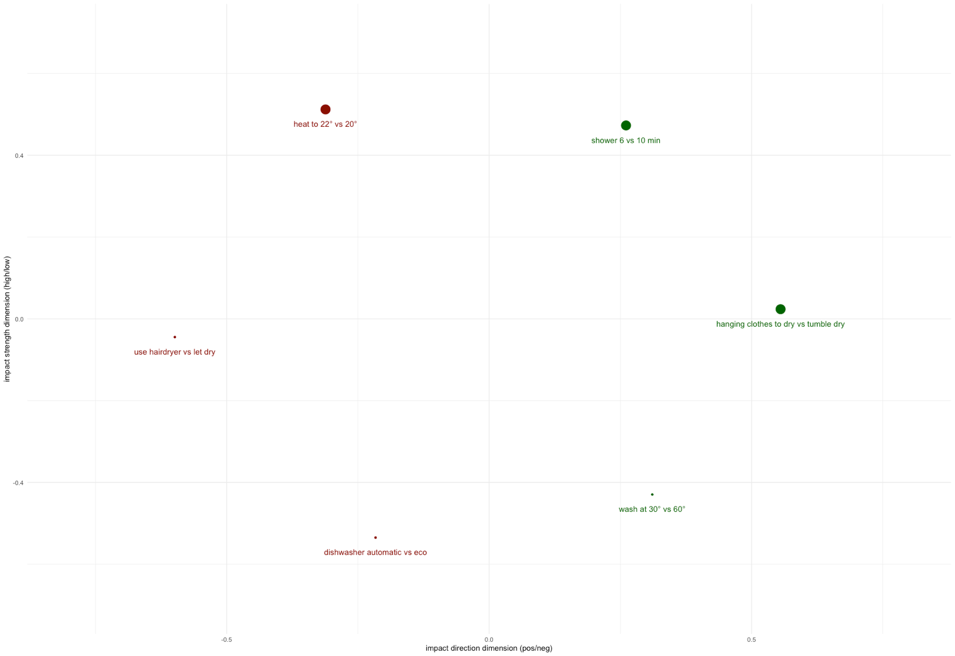

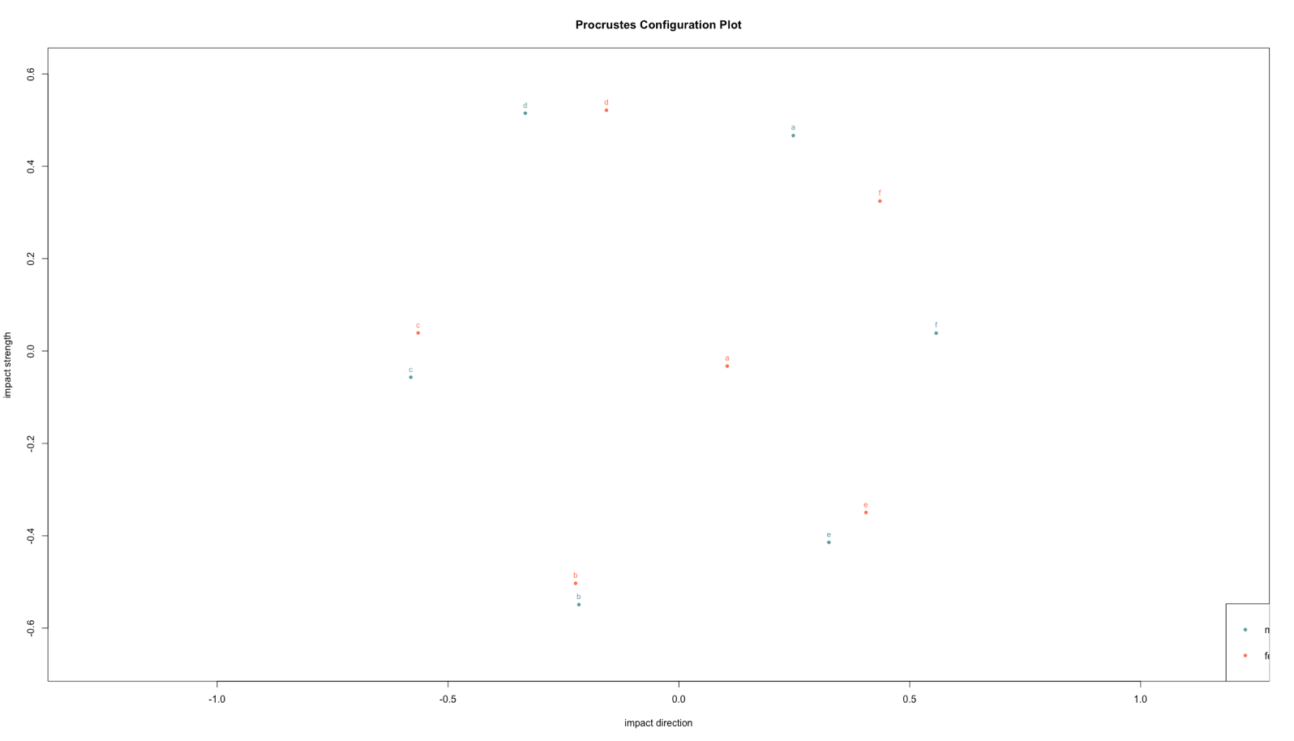

H3

Participants will underestimate the energy consumption associated with energy saving actions.

Mean estimation bias was slightly negative, indicating that overall, averaged across the 6 curtailment behaviors (of which the 3 high-impact behaviors are underestimated and the three low-impact behaviors are overestimated) people tended underestimate slightly more.

In other words, people tended to underestimate KWh overall by a factor of 1.3.

If this is further divided into the low and high impact behaviors this mean that low impact behaviors were overestimated by a factor of about 2 and high impact behaviors were underestimated by a factor of about 3.5

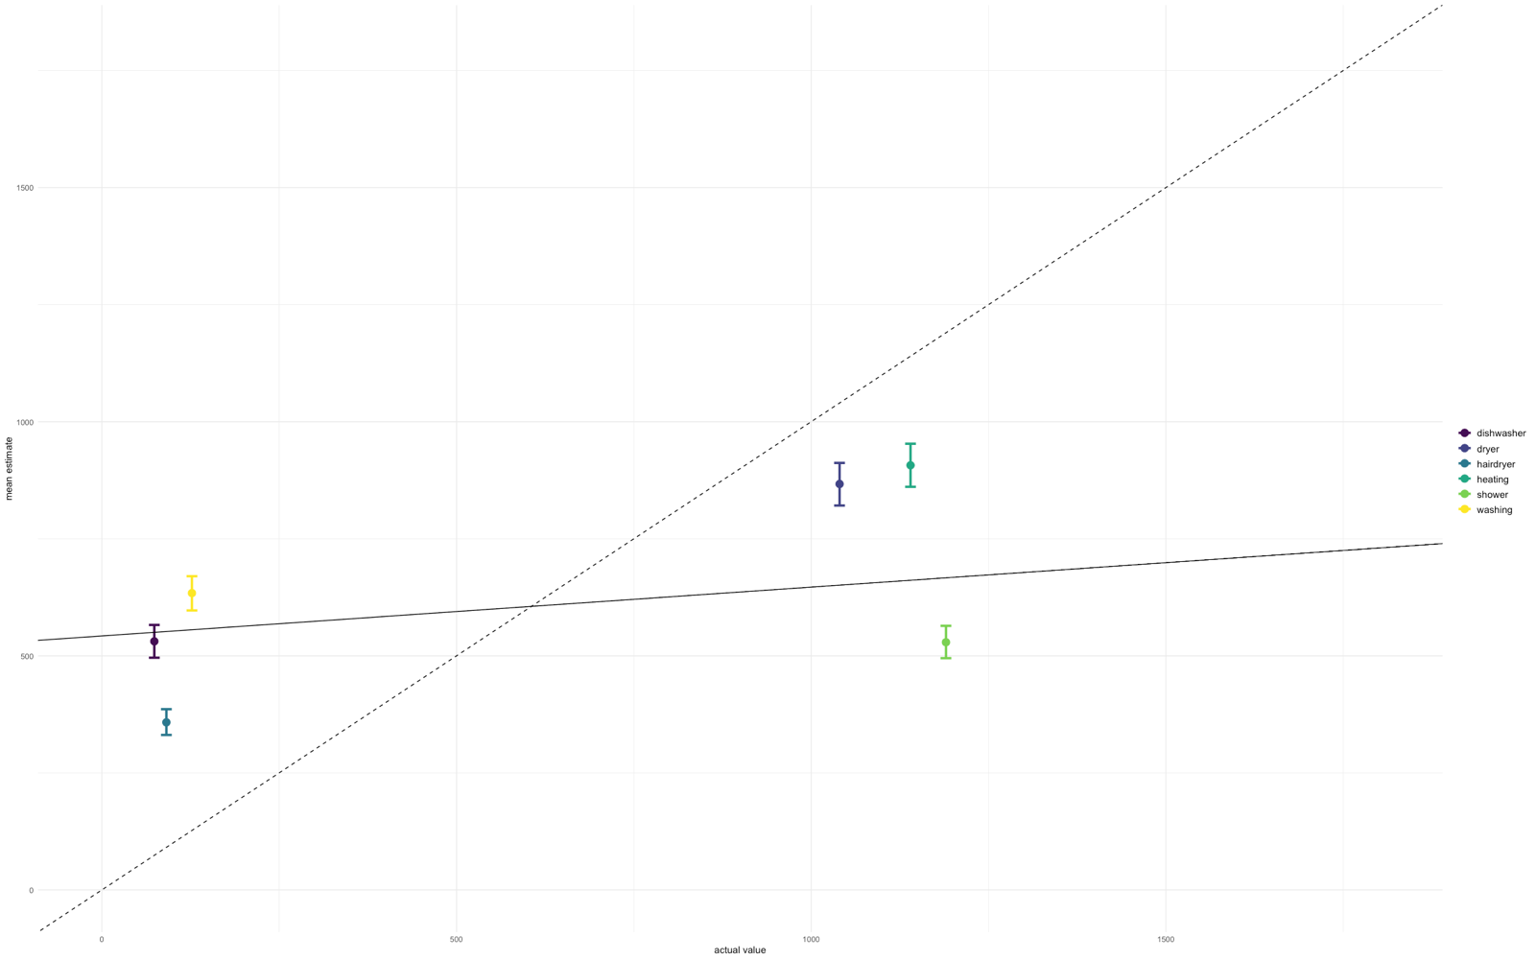

H3a

Frequency of use will predict the accuracy of energy action estimates.

Frequency of use was associated with energy action estimates such that higher frequency of use was associated with a larger mean error in estimation. This suggests that higher frequency of use was associated with less accurate estimates.

With stricter exclusion criteria for accuracy, the estimate reduces to 0.03 vs 0.04 and cc concern to -0.01 but everything remains.

|  |  |  |  |
| --- | --- | --- | --- |
|  | **mean.abs.error** | | |
| *Predictors* | *Estimates* | *CI* | *p* |
| (Intercept) | 0.81 | 0.69 – 0.92 | **<0.001** |
| gender [male] | -0.02 | -0.04 – 0.01 | 0.199 |
| age30-39 | 0.01 | -0.04 – 0.05 | 0.760 |
| age40-49 | -0.05 | -0.09 – -0.00 | **0.030** |
| age50-59 | -0.07 | -0.11 – -0.02 | **0.003** |
| age60-80 | -0.06 | -0.10 – -0.02 | **0.005** |
| income<1'500- 2'499€ 3'100-4'299CHF | -0.03 | -0.07 – 0.01 | 0.165 |
| income [2'500- 4'000€ <4'300- 5'899CHF] | -0.07 | -0.11 – -0.03 | **0.001** |
| income [> 4'000€ >5'900 CHF] | -0.07 | -0.11 – -0.02 | **0.002** |
| country [Switzerland] | 0.00 | -0.03 – 0.03 | 0.928 |
| education [obligatory school] | -0.02 | -0.07 – 0.02 | 0.289 |
| education [middle school] | -0.08 | -0.13 – -0.04 | **<0.001** |
| education [degree] | -0.08 | -0.13 – -0.04 | **0.001** |
| climate concern | -0.02 | -0.03 – -0.01 | **<0.001** |
| mean freq clean | 0.04 | 0.01 – 0.07 | **0.003** |
| V2 | 0.02 | -0.05 – 0.09 | 0.551 |
| Observations | 1522 | | |
| R2 / R2 adjusted | 0.064 / 0.054 | | |

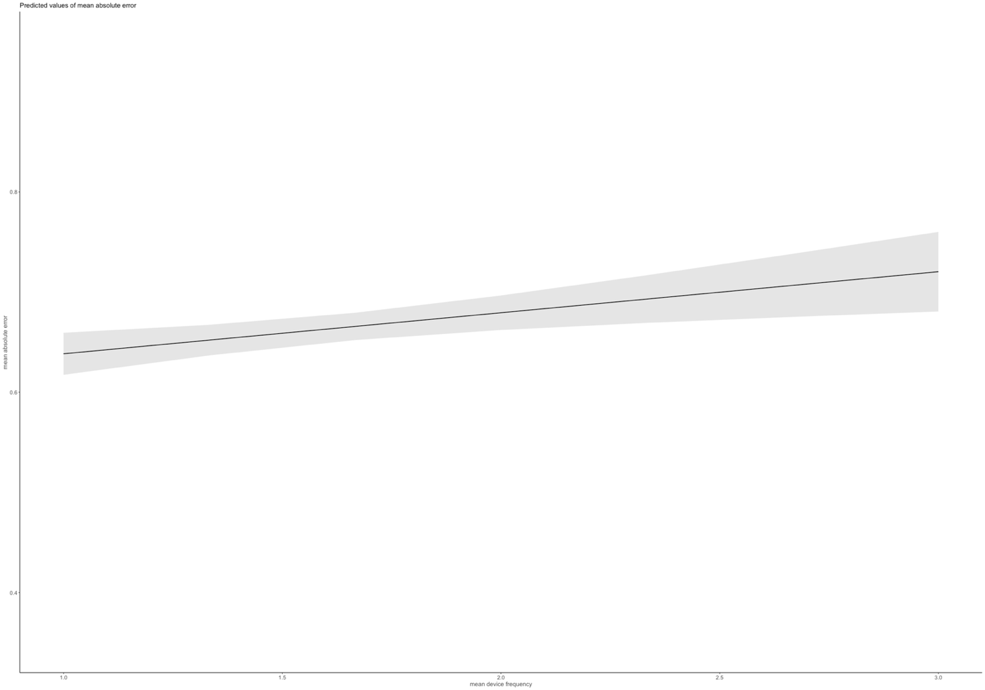

A further posthoc analysis of the mean estimation error (that takes into account the sign of the estimation unlike the mean estimation error), showed that frequency of use was not associated with estimation bias, implying that frequency mostly affects average accuracy negatively, however not due to systematic over or under estimation which seems to be driven in part by climate change concern.

|  |  |  |  |
| --- | --- | --- | --- |
|  | **mean.est.bias** | | |
| *Predictors* | *Estimates* | *CI* | *p* |
| (Intercept) | -0.39 | -0.64 – -0.14 | **0.002** |
| gender [male] | -0.06 | -0.12 – -0.01 | **0.028** |
| age30-39 | -0.07 | -0.16 – 0.03 | 0.177 |
| age40-49 | 0.04 | -0.05 – 0.14 | 0.369 |
| age50-59 | 0.07 | -0.02 – 0.17 | 0.135 |
| age60-80 | 0.05 | -0.04 – 0.14 | 0.283 |
| income<1'500- 2'499€ 3'100-4'299CHF | 0.08 | -0.01 – 0.17 | 0.079 |
| income [2'500- 4'000€ <4'300- 5'899CHF] | 0.09 | -0.00 – 0.18 | 0.056 |
| income [> 4'000€ >5'900 CHF] | 0.16 | 0.07 – 0.26 | **<0.001** |
| country [Switzerland] | 0.16 | 0.11 – 0.22 | **<0.001** |
| education f [middle school] | 0.01 | -0.06 – 0.09 | 0.720 |
| education f [no formal education] | -0.07 | -0.16 – 0.03 | 0.196 |
| education f [obligatory school] | -0.05 | -0.12 – 0.02 | 0.194 |
| climate concern | 0.06 | 0.04 – 0.09 | **<0.001** |
| mean freq clean | -0.03 | -0.09 – 0.03 | 0.284 |
| V2 | -0.13 | -0.28 – 0.02 | 0.092 |
| Observations | 1522 | | |
| R2 / R2 adjusted | 0.072 / 0.063 | | |

Furthermore, running the analysis only with the estimates that refer to a reported frequency (dishwasher, dryer and washing machine)

Reveals similar associations with higher frequency being associated with less accuracy.

However, climate change concern is no longer related to error. Perhaps indicating that for familiar objects judgment accuracy is more affected by frequency of use than by personal values.

|  |  |  |  |
| --- | --- | --- | --- |
|  | **abs.error.3** | | |
| *Predictors* | *Estimates* | *CI* | *p* |
| (Intercept) | 0.71 | 0.60 – 0.83 | **<0.001** |
| gender [male] | -0.04 | -0.07 – -0.02 | **0.002** |
| age30-39 | -0.01 | -0.06 – 0.03 | 0.623 |
| age40-49 | -0.04 | -0.09 – 0.00 | 0.066 |
| age50-59 | -0.07 | -0.12 – -0.03 | **0.002** |
| age60-80 | -0.07 | -0.12 – -0.03 | **0.001** |
| income<1'500- 2'499€ 3'100-4'299CHF | -0.01 | -0.05 – 0.03 | 0.630 |
| income [2'500- 4'000€ <4'300- 5'899CHF] | -0.05 | -0.09 – -0.01 | **0.020** |
| income [> 4'000€ >5'900 CHF] | -0.02 | -0.07 – 0.02 | 0.284 |
| country [Switzerland] | 0.04 | 0.02 – 0.07 | **0.002** |
| education [obligatory school] | -0.01 | -0.06 – 0.03 | 0.517 |
| education [middle school] | -0.08 | -0.12 – -0.03 | **0.002** |
| education [degree] | -0.06 | -0.11 – -0.01 | **0.012** |
| climate concern | -0.01 | -0.02 – 0.01 | 0.298 |
| mean freq clean | 0.03 | 0.00 – 0.06 | **0.023** |
| V2 | 0.01 | -0.06 – 0.08 | 0.764 |
| Observations | 1522 | | |
| R2 / R2 adjusted | 0.050 / 0.041 | | |

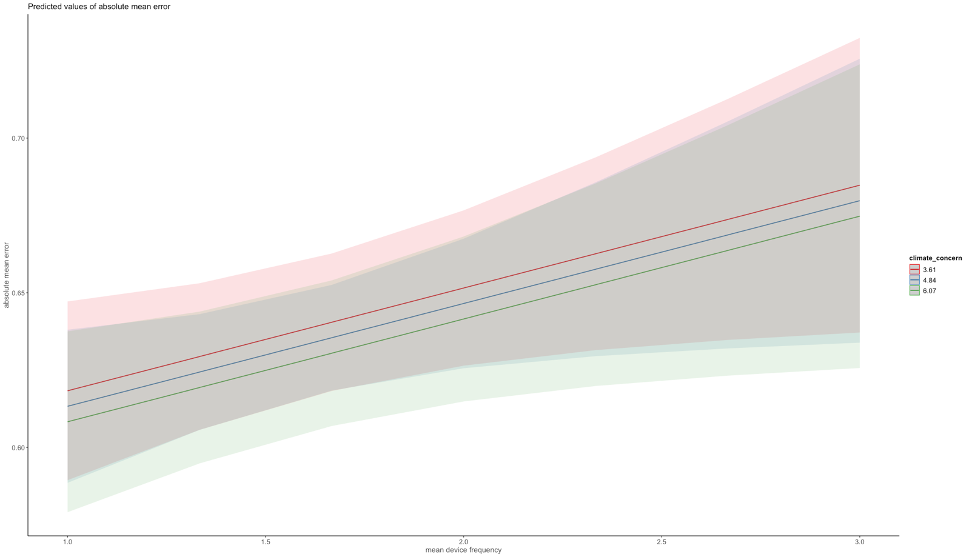

Climate concern is almost completely overlapping, but small main effect for frequency on accuracy

The opposite results for mean estimation bias where cc concern (estimate:0.07; CI: 0.04 – 0.09; p <0.001) is positively associated with bias in a motivated reasoning sort of way perhaps, but frequency does not impact bias. So systematic overestimation might be more driven by values than frequency of use of familiar devices.

Furthermore, a higher weight and differentiation of the impact strength dimension is associated with more underestimation / less overestimation.

|  |  |  |  |
| --- | --- | --- | --- |
|  | **est.bias.3** | | |
| *Predictors* | *Estimates* | *CI* | *p* |
| (Intercept) | -0.15 | -0.41 – 0.11 | 0.261 |
| gender [male] | -0.10 | -0.16 – -0.04 | **0.001** |
| age30-39 | -0.07 | -0.17 – 0.03 | 0.172 |
| age40-49 | 0.04 | -0.06 – 0.14 | 0.471 |
| age50-59 | 0.05 | -0.05 – 0.15 | 0.312 |
| age60-80 | 0.05 | -0.05 – 0.14 | 0.336 |
| income<1'500- 2'499€ 3'100-4'299CHF | 0.06 | -0.03 – 0.15 | 0.201 |
| income [2'500- 4'000€ <4'300- 5'899CHF] | 0.06 | -0.03 – 0.16 | 0.174 |
| income [> 4'000€ >5'900 CHF] | 0.15 | 0.05 – 0.24 | **0.003** |
| country [Switzerland] | 0.17 | 0.11 – 0.23 | **<0.001** |
| education [obligatory school] | 0.02 | -0.08 – 0.12 | 0.642 |
| education [middle school] | 0.10 | -0.01 – 0.21 | 0.063 |
| education [degree] | 0.06 | -0.04 – 0.17 | 0.242 |
| climate concern | 0.07 | 0.04 – 0.09 | **<0.001** |
| mean freq clean | -0.04 | -0.10 – 0.02 | 0.161 |
| V2 | -0.16 | -0.32 – -0.01 | **0.041** |
| Observations | 1522 | | |
| R2 / R2 adjusted | 0.075 / 0.066 | | |

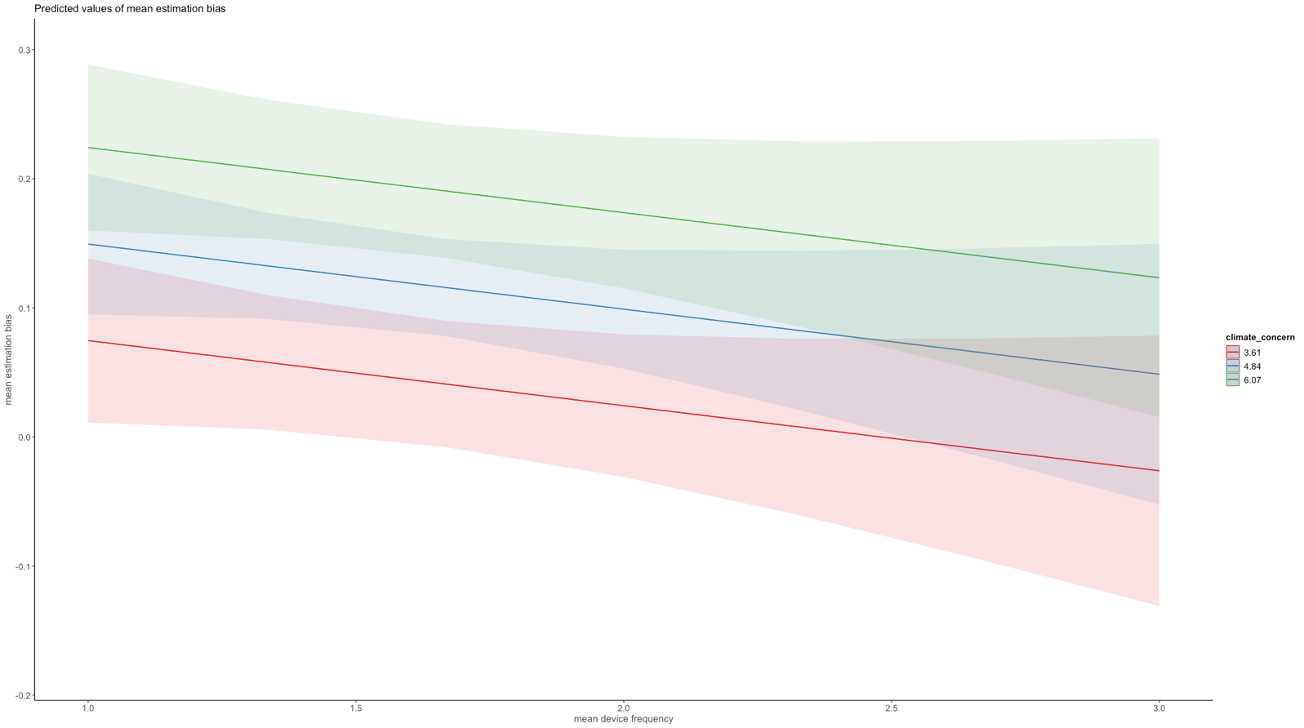

H4a

Climate change concern as well as over-versus underestimation in the accuracy task will significantly predict the number of climate-friendly choices in the product choice task in that higher climate change concern scores and overestimation are associated with a higher likelihood to choose the more energy efficient product options.

Climate concern had a significant positive effect on individual product choice, such that higher climate change concern was associated with a higher likelihood to choose the environmentally friendly product.

Estimation bias by itself was not significantly associated with product choices, the interaction with the choice context however revealed that those overestimating more had a slightly higher chance of choosing the pro-environmental product when the energy efficiency differences between products in the choice was high. *However, big price differences made it less likely for those overestimating more to choose the pro-environmental product.*

Analyzing judgment error (inaccuracies disregarding the sign of the inaccuracy) revelaed that those with a more accurate understanding (low judgment error) reacted strongly to energy efficiency differences such that they were much more likely to choose the pro-environmental product when the choice was between two product differing more in energy efficiency, whereas those displaying less accurate kWh estimates seemed to not to react to these differences, or less strongly.



|  |  |  |  |  |  |  |  |  |  |  |  |  |
| --- | --- | --- | --- | --- | --- | --- | --- | --- | --- | --- | --- | --- |
| ***CHOICE***  *Predictors* | *Odds Ratios* | *CI* | *p* |  |  | |  | |  | |  | |
| (Intercept) | 0.11 | 0.03 – 0.34 | **<0.001** |  |  | |  | |  | |  | |
| price level [2] | 0.49 | 0.27 – 0.86 | **0.013** |  | |  | |  | |  | |  | |
| energy level [2] | 2.87 | 1.67 – 4.93 | **<0.001** |  |  | |  | |  | |  | |
| climate concern | 1.23 | 1.07 – 1.41 | **0.003** |  |  | |  | |  | |  | |
| mean est bias | 1.00 | 0.75 – 1.35 | 0.991 |  |  | |  | |  | |  | |
| country [Switzerland] | 2.14 | 1.57 – 2.93 | **<0.001** |  |  | |  | |  | |  | |
| trust gov | 1.12 | 0.99 – 1.26 | 0.061 |  |  | |  | |  | |  | |
| V2 | 1.05 | 0.51 – 2.12 | 0.903 |  |  | |  | |  | |  | |
| gender [male] | 1.05 | 0.81 – 1.38 | 0.708 |  |  | |  | |  | |  | |
| age30-39 | 1.15 | 0.72 – 1.83 | 0.549 |  |  | |  | |  | |  | |
| age40-49 | 1.31 | 0.83 – 2.06 | 0.240 |  |  | |  | |  | |  | |
| age50-59 | 1.26 | 0.81 – 1.95 | 0.313 |  |  | |  | |  | |  | |
| age60-80 | 1.22 | 0.80 – 1.86 | 0.346 |  |  | |  | |  | |  | |
| income [<1'500€ <3'100CHF] | 1.16 | 0.76 – 1.77 | 0.482 |  |  | |  | |  | |  | |
| income [> 4'000€ >5'900] | 2.06 | 1.42 – 3.00 | **<0.001** |  |  | |  | |  | |  | |
| income [2'500- 4'000€ <4'300- 5'899CHF] | 1.49 | 1.04 – 2.12 | **0.029** |  |  | |  | |  | |  | |
| education [middle school] | 0.89 | 0.62 – 1.27 | 0.516 |  |  | |  | |  | |  | |
| education [no formal education] | 1.61 | 0.99 – 2.61 | 0.053 |  |  | |  | |  | |  | |
| education [obligatory school] | 1.26 | 0.90 – 1.78 | 0.176 |  |  | |  | |  | |  | |
| price level [2] × energy level [2] | 0.33 | 0.26 – 0.43 | **<0.001** |  |  | |  | |  | |  | |
| price level [2] × climate concern | 0.95 | 0.85 – 1.06 | 0.326 |  |  | |  | |  | |  | |
| price level [2] × mean est bias | 0.67 | 0.52 – 0.87 | **0.002** |  |  | |  | |  | |  | |
| energy level [2] × mean est bias | 1.29 | 1.00 – 1.64 | **0.046** |  |  | |  | |  | |  | |
| energy level [2] × climate concern | 1.18 | 1.07 – 1.31 | **0.002** |  |  | |  | |  | |  | |
| price level [2] × country [CH] | 0.22 | 0.16 – 0.28 | **<0.001** |  |  | |  | |  | |  | |
| energy level [2] × country [CH] | 0.71 | 0.55 – 0.92 | **0.010** |  |  | |  | |  | |  | |
| **Random Effects** | | | |  |  | |  | |  | |  | |
| σ2 | 3.29 | | |  |  | |  | |  | |  | |
| τ00 ResponseId | 3.78 | | |  |  | |  | |  | |  | |
| ICC | 0.53 | | |  |  | |  | |  | |  | |
| N ResponseId | 1139 | | |  |  | |  | |  | |  | |
| Observations | 7973 | | |  |  | |  | |  | |  | |
| Marginal R2 / Conditional R2 | 0.242 / 0.647 | | |  |  | |  | |  | |  | |

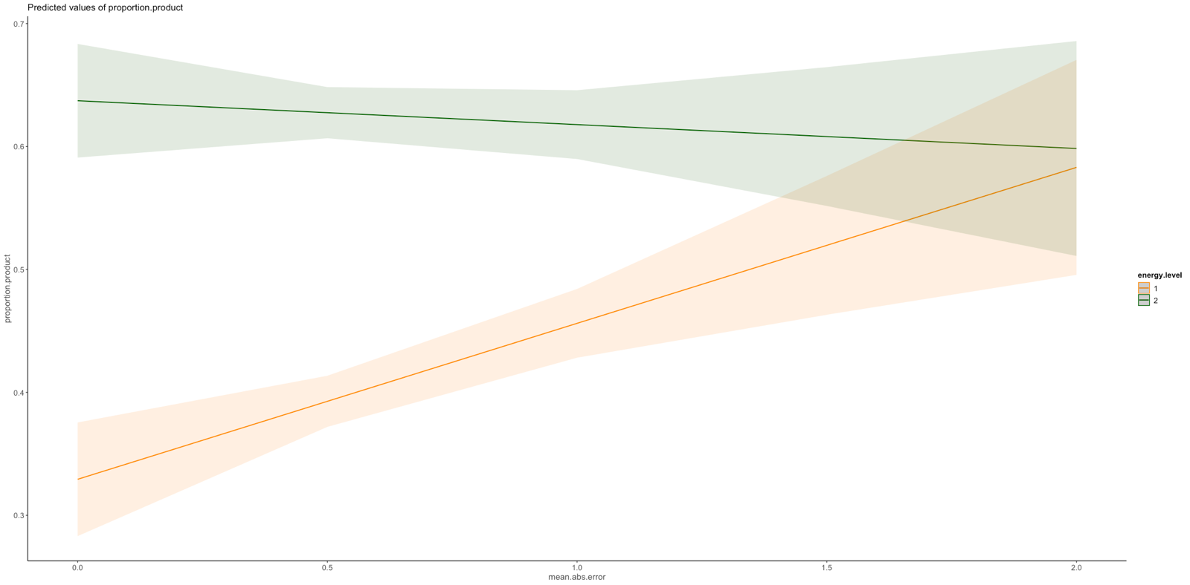

H4b

Individual weights of the impact strength dimension will predict the number of climate-friendly choices in the product choice task in that higher scores on the impact strength dimension variable are associated with a higher likelihood to choose the more energy efficient product options.

|  |  |  |  |
| --- | --- | --- | --- |
|  | **choice** | | |
| *Predictors* | *Odds Ratios* | *CI* | *p* |
| (Intercept) | 1.16 | 0.60 – 2.25 | 0.658 |
| est binary [over] | 0.93 | 0.73 – 1.18 | 0.534 |
| concern scaled | 1.30 | 1.18 – 1.43 | **<0.001** |
| V2 | 0.96 | 0.52 – 1.77 | 0.886 |
| country [Switzerland] | 0.10 | 0.08 – 0.13 | **<0.001** |
| **Random Effects** | | | |
| σ2 | 3.29 | | |
| τ00 ResponseId | 3.75 | | |
| ICC | 0.53 | | |
| N ResponseId | 1522 | | |
| Observations | 10654 | | |
| Marginal R2 / Conditional R2 | * 1. 0.609 | | |

The individual weight placed on the impact strength dimension was not related to pro-environmental product choices

Not pre-registered

Predicting energy policy support

Connection judgment and policy decision with interaction time* concern; time*sum.product & time*judgment error

Logisitc regression model

glmer(decision ~ co2 + tax +energieabhaengigkeit +

gender + age + income + country + education +

trust.gov.scaled + politicalorientation.scaled +

(mean.abs.error + concern.scaled + Sum.product.scaled)*zeitpunkt +

(1 + tax + co2 + energieabhaengigkeit + zeitpunkt|ResponseId),

family="binomial",

data=data.decision)

|  |  |  |  |
| --- | --- | --- | --- |
|  | **decision** | | |
| *Predictors* | *Odds Ratios* | *CI* | *p* |
| (Intercept) | 9.04 | 5.13 – 15.92 | **<0.001** |
| co2-30% CO2 | 1.69 | 1.54 – 1.86 | **<0.001** |
| tax: +6% | 0.04 | 0.03 – 0.05 | **<0.001** |
| energieabhaengigkeit: +20% | 1.42 | 1.30 – 1.56 | **<0.001** |
| gender: male | 1.08 | 0.88 – 1.33 | 0.479 |
| age30-39 | 0.87 | 0.62 – 1.23 | 0.439 |
| age40-49 | 0.68 | 0.48 – 0.96 | **0.031** |
| age50-59 | 0.55 | 0.39 – 0.78 | **0.001** |
| age60-80 | 0.42 | 0.30 – 0.58 | **<0.001** |
| income<1'500- 2'499€ 3'100-4'299CHF | 0.77 | 0.56 – 1.07 | 0.118 |
| income: 2'500- 4'000€ <4'300- 5'899CHF | 0.65 | 0.47 – 0.89 | **0.008** |
| income: > 4'000€ >5'900 CHF | 0.85 | 0.61 – 1.18 | 0.325 |
| country: Switzerland | 1.10 | 0.89 – 1.35 | 0.382 |
| education: obligatory school | 1.23 | 0.88 – 1.73 | 0.226 |
| education: middle school | 1.11 | 0.77 – 1.60 | 0.579 |
| education: degree | 1.14 | 0.79 – 1.63 | 0.485 |
| trust.gov.scaled | 1.34 | 1.22 – 1.47 | **<0.001** |
| politicalorientation.scaled | 0.88 | 0.79 – 0.98 | **0.019** |
| mean absolute error | 0.65 | 0.42 – 1.00 | **0.050** |
| concern.scaled | 2.12 | 1.90 – 2.37 | **<0.001** |
| Sum.product.scaled | 1.11 | 0.99 – 1.26 | 0.082 |
| implementation time: in 7 Jahren | 0.07 | 0.05 – 0.11 | **<0.001** |
| mean.abs.error:zeitpunktin 7 Jahren | 6.30 | 3.49 – 11.37 | **<0.001** |
| concern.scaled:zeitpunktin 7 Jahren | 0.50 | 0.44 – 0.58 | **<0.001** |
| Sum.product.scaled:zeitpunktin 7 Jahren | 0.80 | 0.68 – 0.95 | **0.008** |
| **Random Effects** | | | |
| σ2 | 3.29 | | |
| τ00 ResponseId | 4.85 | | |
| τ11 ResponseId.tax+6% | 10.04 | | |
| τ11 ResponseId.co2-30% CO2 | 0.61 | | |
| τ11 ResponseId.energieabhaengigkeit+20% | 0.19 | | |
| τ11 ResponseId.zeitpunktin 7 Jahren | 6.83 | | |
| ρ01 | -0.37 | | |
|  | -0.28 | | |
|  | -0.28 | | |
|  | -0.23 | | |
| ICC | 0.71 | | |
| N ResponseId | 1547 | | |
| Observations | 24752 | | |
| Marginal R2 / Conditional R2 | 0.275 / 0.787 | | |

|  |  |  |  |
| --- | --- | --- | --- |
| emotions.re.pos.scaled | 1.11 | 1.00 – 1.24 | 0.052 |

Is highly correlated with concern though so left it out of the model

Policy support predicted by individual pro-environmental choices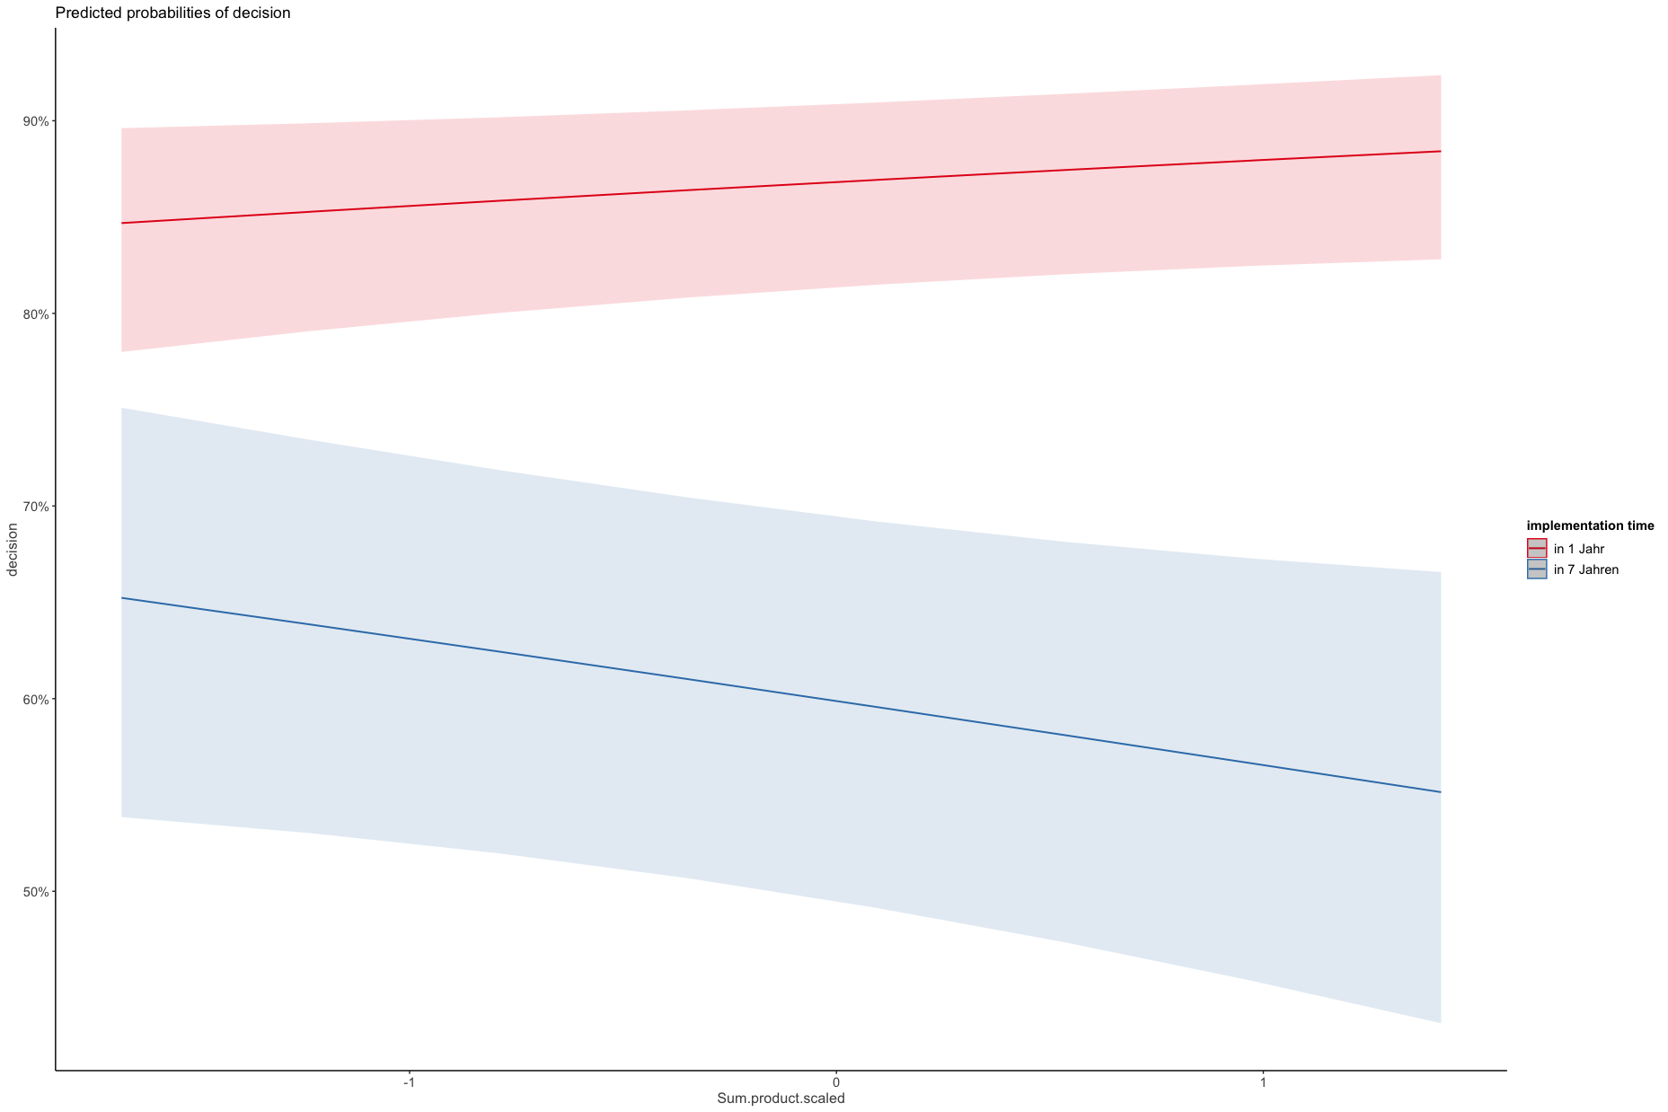

Policy support predicted by judgment error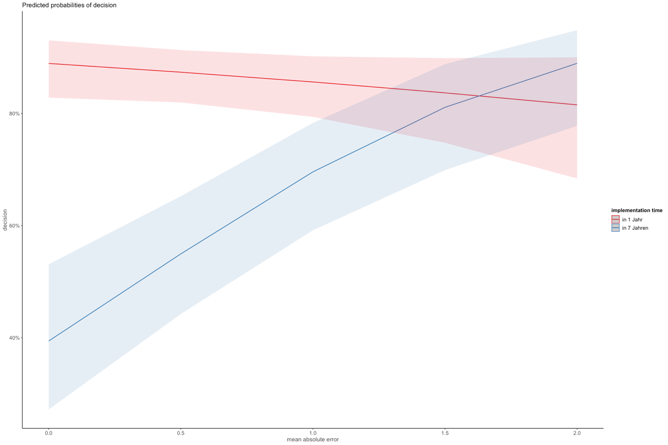

Policy support predicted by climate change concern

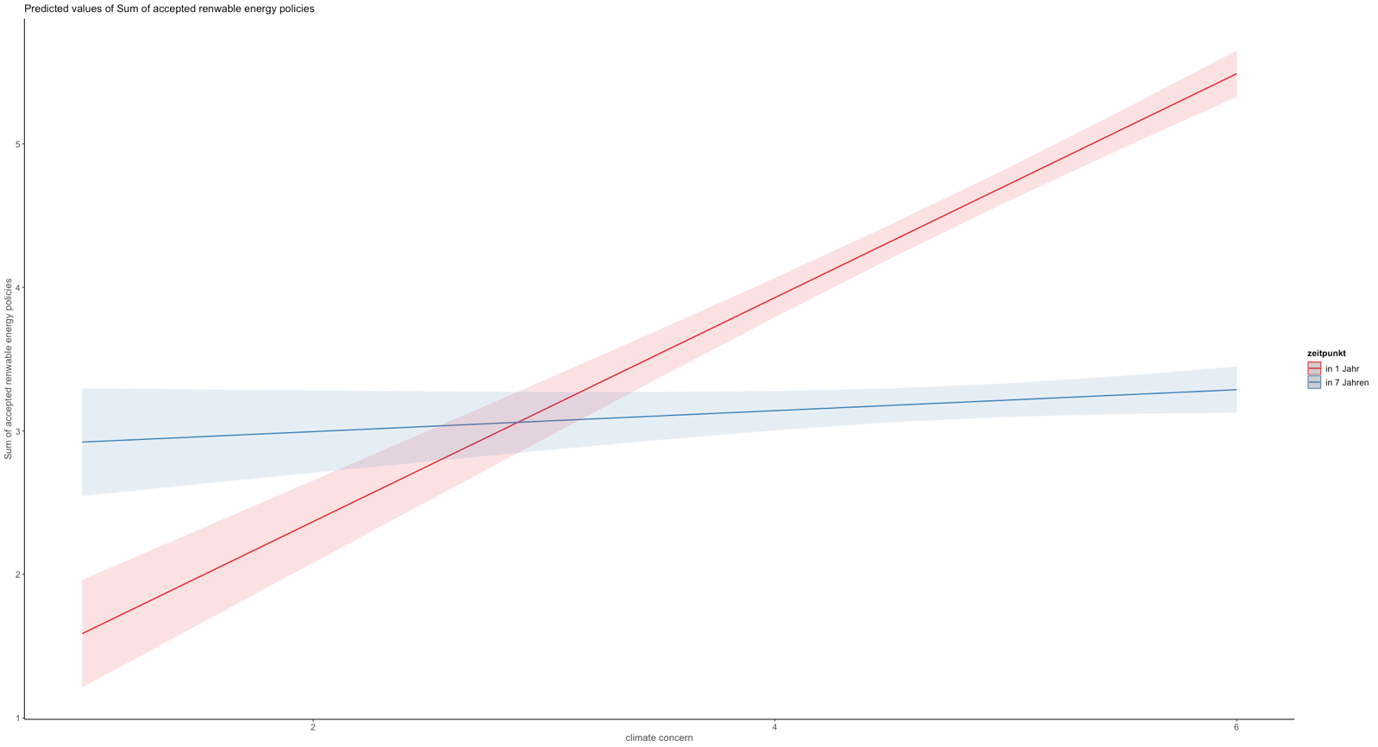

Policy support predicted by judgment error **and** climate change concern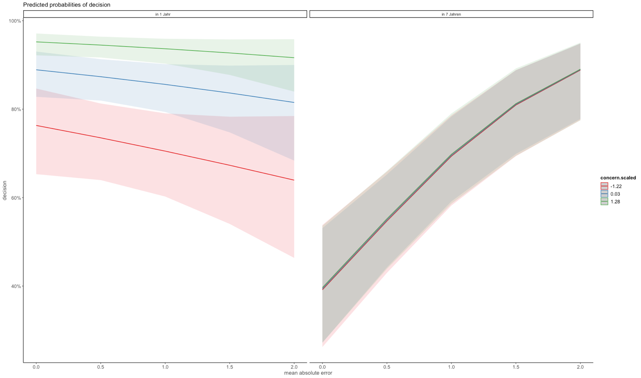

Stepwise:

First without either judgment error or Sum of pro-environemtal product choices

|  |  |  |  |
| --- | --- | --- | --- |
|  | **decision** | | |
| *Predictors* | *Odds Ratios* | *CI* | *p* |
| (Intercept) | 7.05 | 4.44 – 11.21 | **<0.001** |
| co2-30% CO2 | 1.74 | 1.58 – 1.92 | **<0.001** |
| tax: +6% | 0.04 | 0.03 – 0.05 | **<0.001** |
| energieabhaengigkeit: +20% | 1.41 | 1.30 – 1.55 | **<0.001** |
| implementation time: in 7 Jahren | 0.23 | 0.19 – 0.27 | **<0.001** |
| concern.scaled | 2.25 | 2.01 – 2.51 | **<0.001** |
| gender: male | 1.07 | 0.87 – 1.31 | 0.538 |
| age30-39 | 0.83 | 0.58 – 1.17 | 0.277 |
| age40-49 | 0.66 | 0.46 – 0.93 | **0.018** |
| age50-59 | 0.54 | 0.38 – 0.76 | **<0.001** |
| age60-80 | 0.41 | 0.29 – 0.56 | **<0.001** |
| income<1'500- 2'499€ 3'100-4'299CHF | 0.77 | 0.56 – 1.06 | 0.115 |
| income: 2'500- 4'000€ <4'300- 5'899CHF | 0.65 | 0.47 – 0.89 | **0.008** |
| income: > 4'000€ >5'900 CHF | 0.87 | 0.63 – 1.20 | 0.386 |
| country: Switzerland | 1.13 | 0.92 – 1.39 | 0.258 |
| education: obligatory school | 1.21 | 0.86 – 1.70 | 0.277 |
| education: middle school | 1.07 | 0.74 – 1.54 | 0.714 |
| education: degree | 1.09 | 0.76 – 1.57 | 0.634 |
| trust.gov.scaled | 1.33 | 1.22 – 1.46 | **<0.001** |
| politicalorientation.scaled | 0.89 | 0.80 – 1.00 | **0.041** |
| zeitpunktin 7 Jahren:concern.scaled | 0.45 | 0.39 – 0.52 | **<0.001** |
| **Random Effects** | | | |
| σ2 | 3.29 | | |
| τ00 ResponseId | 4.97 | | |
| τ11 ResponseId.tax+6% | 10.11 | | |
| τ11 ResponseId.co2-30% CO2 | 0.60 | | |
| τ11 ResponseId.energieabhaengigkeit+20% | 0.20 | | |
| τ11 ResponseId.zeitpunktin 7 Jahren | 7.19 | | |
| ρ01 | -0.38 | | |
|  | -0.27 | | |
|  | -0.25 | | |
|  | -0.27 | | |
| ICC | 0.71 | | |
| N ResponseId | 1547 | | |
| Observations | 24752 | | |
| Marginal R2 / Conditional R2 | 0.270 / 0.789 | | |

Versus model with both sum product and error interacted 0.275 / 0.787 -> so ?

Separate for judgment error (=without Sum of pro-environmental product choices)

|  |  |  |  |
| --- | --- | --- | --- |
|  | **decision** | | |
| *Predictors* | *Odds Ratios* | *CI* | *p* |
| (Intercept) | 6.96 | 4.01 – 12.07 | **<0.001** |
| co2-30% CO2 | 1.64 | 1.49 – 1.81 | **<0.001** |
| tax: +6% | 0.04 | 0.04 – 0.05 | **<0.001** |
| energieabhaengigkeit: +20% | 1.41 | 1.29 – 1.53 | **<0.001** |
| gender: male | 1.09 | 0.88 – 1.33 | 0.434 |
| age30-39 | 0.75 | 0.54 – 1.06 | 0.106 |
| age40-49 | 0.57 | 0.40 – 0.80 | **0.001** |
| age50-59 | 0.46 | 0.33 – 0.65 | **<0.001** |
| age60-80 | 0.35 | 0.25 – 0.48 | **<0.001** |
| income: <1’500€ <3’100CHF | 1.46 | 1.06 – 2.01 | **0.020** |
| income: > 4’000€ >5’900 CHF | 1.14 | 0.85 – 1.51 | 0.380 |
| income: 2’500- 4’000€ <4’300- 5’899CHF | 0.91 | 0.69 – 1.21 | 0.519 |
| country: Switzerland | 1.14 | 0.92 – 1.40 | 0.227 |
| education: obligatory school | 1.39 | 0.99 – 1.95 | 0.058 |
| education: middle school | 1.20 | 0.84 – 1.72 | 0.324 |
| education: degree | 1.25 | 0.88 – 1.79 | 0.218 |
| trust.gov.scaled | 1.31 | 1.20 – 1.43 | **<0.001** |
| politicalorientation.scaled | 0.88 | 0.79 – 0.99 | **0.027** |
| mean absolute error | 0.62 | 0.40 – 0.97 | **0.034** |
| concern.scaled | 2.21 | 1.98 – 2.47 | **<0.001** |
| implementation time: in 7 Jahren | 0.07 | 0.05 – 0.11 | **<0.001** |
| mean.abs.error:zeitpunktin 7 Jahren | 6.24 | 3.45 – 11.29 | **<0.001** |
| concern.scaled:zeitpunktin 7 Jahren | 0.47 | 0.41 – 0.54 | **<0.001** |
| **Random Effects** | | | |
| σ2 | 3.29 | | |
| τ00 ResponseId | 4.92 | | |
| τ11 ResponseId.tax+6% | 9.83 | | |
| τ11 ResponseId.co2-30% CO2 | 0.62 | | |
| τ11 ResponseId.energieabhaengigkeit+20% | 0.19 | | |
| τ11 ResponseId.zeitpunktin 7 Jahren | 6.97 | | |
| ρ01 | -0.39 | | |
|  | -0.29 | | |
|  | -0.32 | | |
|  | -0.21 | | |
| ICC | 0.70 | | |
| N ResponseId | 1547 | | |
| Observations | 24752 | | |
| Marginal R2 / Conditional R2 | 0.272 / 0.784 | | |

This seems to explain marginally less ?? than model without error 0.270 / 0.789

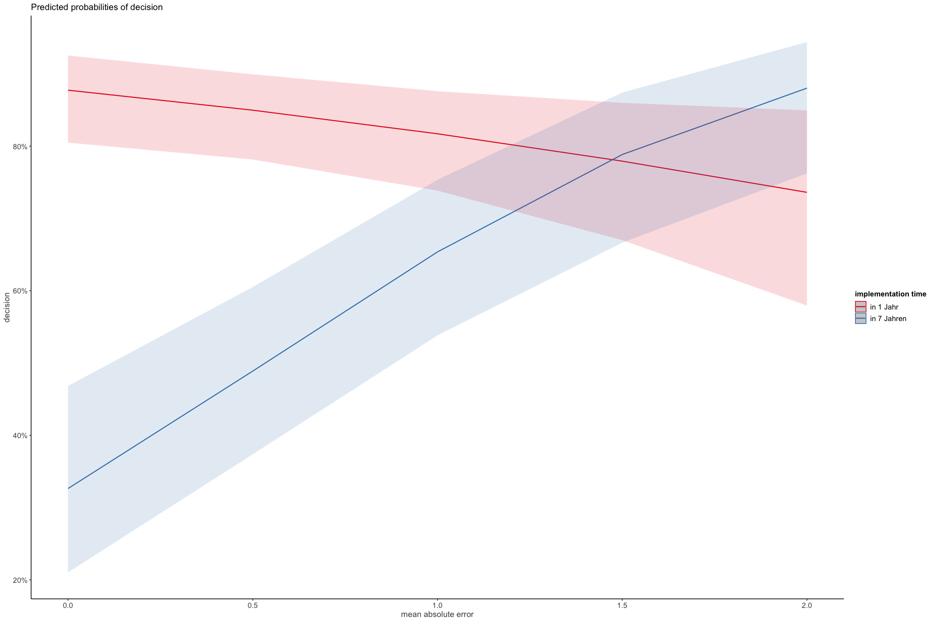

Separate for Sum of pro-environmental product choices (=without judgment error)

Scaled Sum products

|  |  |  |  |
| --- | --- | --- | --- |
|  | **decision** | | |
| *Predictors* | *Odds Ratios* | *CI* | *p* |
| (Intercept) | 5.48 | 3.49 – 8.60 | **<0.001** |
| co2-30% CO2 | 1.72 | 1.56 – 1.89 | **<0.001** |
| tax: +6% | 0.04 | 0.03 – 0.05 | **<0.001** |
| energieabhaengigkeit: +20% | 1.43 | 1.31 – 1.56 | **<0.001** |
| gender: male | 1.10 | 0.89 – 1.35 | 0.363 |
| age30-39 | 0.83 | 0.59 – 1.17 | 0.294 |
| age40-49 | 0.66 | 0.47 – 0.93 | **0.018** |
| age50-59 | 0.52 | 0.37 – 0.74 | **<0.001** |
| age60-80 | 0.40 | 0.29 – 0.55 | **<0.001** |
| income: <1’500€ <3’100CHF | 1.39 | 1.01 – 1.92 | **0.044** |
| income: > 4’000€ >5’900 CHF | 1.06 | 0.79 – 1.42 | 0.685 |
| income: 2’500- 4’000€ <4’300- 5’899CHF | 0.85 | 0.64 – 1.13 | 0.257 |
| country: Switzerland | 1.09 | 0.88 – 1.34 | 0.444 |
| education: obligatory school | 1.23 | 0.87 – 1.73 | 0.236 |
| education: middle school | 1.10 | 0.76 – 1.59 | 0.605 |
| education: degree | 1.13 | 0.79 – 1.61 | 0.519 |
| trust.gov.scaled | 1.33 | 1.22 – 1.46 | **<0.001** |
| politicalorientation.scaled | 0.89 | 0.80 – 0.99 | **0.032** |
| Sum.product.scaled | 1.13 | 1.00 – 1.28 | **0.048** |
| concern.scaled | 2.21 | 1.98 – 2.48 | **<0.001** |
| implementation time: in 7 Jahren | 0.23 | 0.19 – 0.27 | **<0.001** |
| Sum.product.scaled:zeitpunktin 7 Jahren | 0.80 | 0.67 – 0.94 | **0.007** |
| concern.scaled:zeitpunktin 7 Jahren | 0.45 | 0.39 – 0.52 | **<0.001** |
| **Random Effects** | | | |
| σ2 | 3.29 | | |
| τ00 ResponseId | 5.08 | | |
| τ11 ResponseId.tax+6% | 9.92 | | |
| τ11 ResponseId.co2-30% CO2 | 0.62 | | |
| τ11 ResponseId.energieabhaengigkeit+20% | 0.19 | | |
| τ11 ResponseId.zeitpunktin 7 Jahren | 7.01 | | |
| ρ01 | -0.39 | | |
|  | -0.27 | | |
|  | -0.28 | | |
|  | -0.26 | | |
| ICC | 0.71 | | |
| N ResponseId | 1547 | | |
| Observations | 24752 | | |
| Marginal R2 / Conditional R2 | 0.274 / 0.787 | | |

This seems to explain marginally more for fixed and less for random than model without Sum.product 0.270 / 0.789

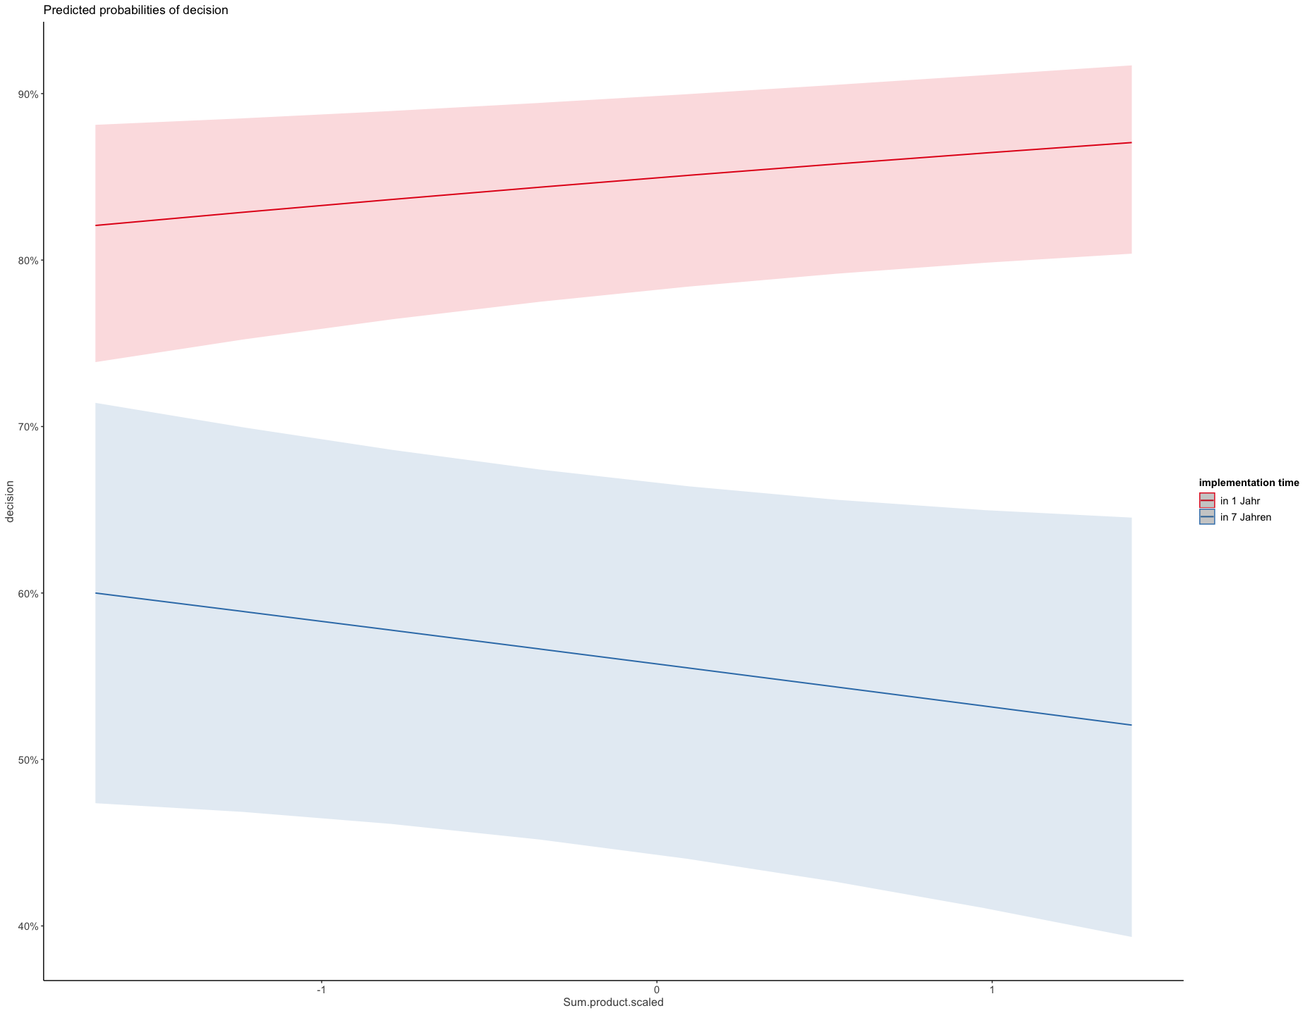

Non-scaled Sum products

|  |  |  |  |
| --- | --- | --- | --- |
|  | **decision** | | |
| *Predictors* | *Odds Ratios* | *CI* | *p* |
| (Intercept) | 4.76 | 2.93 – 7.72 | **<0.001** |
| co2-30% CO2 | 1.69 | 1.54 – 1.86 | **<0.001** |
| tax: +6% | 0.04 | 0.03 – 0.05 | **<0.001** |
| energieabhaengigkeit: +20% | 1.41 | 1.29 – 1.54 | **<0.001** |
| gender: male | 1.02 | 0.83 – 1.25 | 0.885 |
| age30-39 | 0.87 | 0.61 – 1.23 | 0.422 |
| age40-49 | 0.65 | 0.46 – 0.92 | **0.014** |
| age50-59 | 0.54 | 0.39 – 0.76 | **<0.001** |
| age60-80 | 0.41 | 0.29 – 0.56 | **<0.001** |
| income: <1’500€ <3’100CHF | 1.39 | 1.01 – 1.92 | **0.043** |
| income: > 4’000€ >5’900 CHF | 1.18 | 0.88 – 1.58 | 0.267 |
| income: 2’500- 4’000€ <4’300- 5’899CHF | 0.85 | 0.64 – 1.12 | 0.251 |
| country: Switzerland | 1.12 | 0.91 – 1.38 | 0.291 |
| education: obligatory school | 1.26 | 0.90 – 1.78 | 0.179 |
| education: middle school | 1.09 | 0.76 – 1.57 | 0.640 |
| education: degree | 1.14 | 0.79 – 1.63 | 0.481 |
| trust.gov.scaled | 1.33 | 1.22 – 1.46 | **<0.001** |
| politicalorientation.scaled | 0.85 | 0.76 – 0.95 | **0.004** |
| Sum of proenvironmental product choices | 1.03 | 0.97 – 1.08 | 0.338 |
| concern.scaled | 2.18 | 1.95 – 2.44 | **<0.001** |
| implementation time: in 7 Jahren | 0.27 | 0.19 – 0.38 | **<0.001** |
| Sum.product:zeitpunktin 7 Jahren | 0.96 | 0.89 – 1.03 | 0.251 |
| concern.scaled:zeitpunktin 7 Jahren | 0.44 | 0.38 – 0.51 | **<0.001** |
| **Random Effects** | | | |
| σ2 | 3.29 | | |
| τ00 ResponseId | 5.07 | | |
| τ11 ResponseId.tax+6% | 10.30 | | |
| τ11 ResponseId.co2-30% CO2 | 0.60 | | |
| τ11 ResponseId.energieabhaengigkeit+20% | 0.22 | | |
| τ11 ResponseId.zeitpunktin 7 Jahren | 7.27 | | |
| ρ01 | -0.36 | | |
|  | -0.31 | | |
|  | -0.27 | | |
|  | -0.28 | | |
| ICC | 0.71 | | |
| N ResponseId | 1547 | | |
| Observations | 24752 | | |
| Marginal R2 / Conditional R2 | 0.267 / 0.789 | | |
|  |  | | |

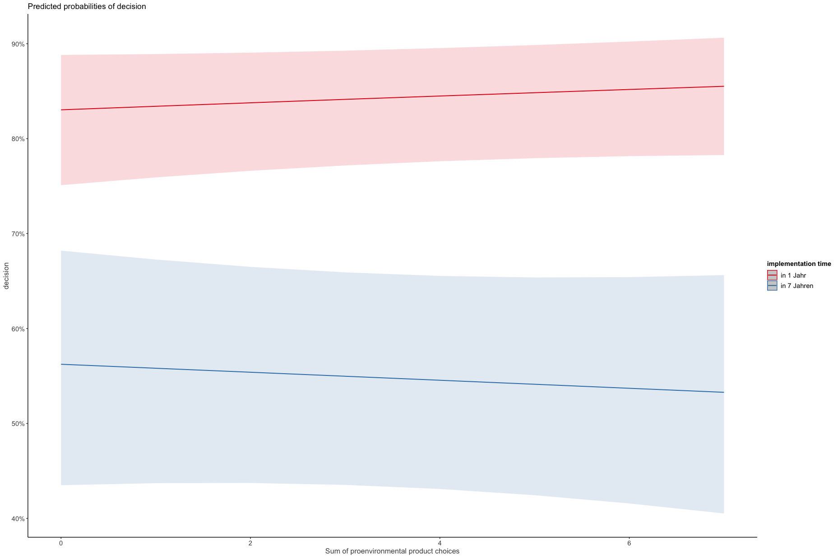

Predicting product choice

für einzelne choices

model.choice.error.s <- glmer(choice ~ price.level * energy.level + price.level*(climate_concern+mean.abs.error) +

(mean.abs.error+ climate_concern)* energy.level +

country*price.level + country*energy.level + trust.gov +

mean.abs.error + V2+ gender + age + income + education +

(1 + price.level + energy.level| ResponseId),

data=data.everything, family=”binomial”)

|  |  |  |  |
| --- | --- | --- | --- |
|  | **choice** | | |
| *Predictors* | *Odds Ratios* | *CI* | *p* |
| (Intercept) | 0.12 | 0.04 – 0.33 | **<0.001** |
| price level [2] | 0.26 | 0.14 – 0.49 | **<0.001** |
| energy level [2] | 4.98 | 2.87 – 8.66 | **<0.001** |
| climate concern | 1.27 | 1.13 – 1.42 | **<0.001** |
| mean abs error | 1.31 | 0.80 – 2.13 | 0.283 |
| country [Switzerland] | 2.17 | 1.68 – 2.81 | **<0.001** |
| trust gov | 1.08 | 0.97 – 1.19 | 0.152 |
| V2 | 0.88 | 0.48 – 1.59 | 0.669 |
| gender [male] | 1.10 | 0.88 – 1.38 | 0.407 |
| age30-39 | 1.09 | 0.75 – 1.58 | 0.666 |
| age40-49 | 1.32 | 0.91 – 1.92 | 0.142 |
| age50-59 | 1.16 | 0.80 – 1.67 | 0.441 |
| age60-80 | 1.49 | 1.05 – 2.13 | **0.026** |
| income [<1’500€ <3’100CHF] | 0.99 | 0.70 – 1.41 | 0.968 |
| income [> 4’000€ >5’900 CHF] | 1.85 | 1.35 – 2.53 | **<0.001** |
| income [2’500- 4’000€ <4’300- 5’899CHF] | 1.41 | 1.04 – 1.91 | **0.028** |
| education [middle school] | 0.90 | 0.66 – 1.23 | 0.496 |
| education [no formal education] | 1.07 | 0.72 – 1.58 | 0.744 |
| education [obligatory school] | 1.03 | 0.77 – 1.37 | 0.858 |
| price level [2] × energy level [2] | 0.38 | 0.29 – 0.50 | **<0.001** |
| price level [2] × climate concern | 0.92 | 0.84 – 1.02 | 0.114 |
| price level [2] × mean abs error | 3.69 | 2.37 – 5.75 | **<0.001** |
| energy level [2] × mean abs error | 0.42 | 0.28 – 0.63 | **<0.001** |
| energy level [2] × climate concern | 1.15 | 1.05 – 1.26 | **0.002** |
| price level [2] × country [Switzerland] | 0.19 | 0.15 – 0.25 | **<0.001** |
| energy level [2] × country [Switzerland] | 0.75 | 0.60 – 0.93 | **0.009** |
| **Random Effects** | | | |
| σ2 | 3.29 | | |
| τ00 ResponseId | 3.38 | | |
| τ11 ResponseId.price.level2 | 0.43 | | |
| τ11 ResponseId.energy.level2 | 0.01 | | |
| ρ01 | 0.33 | | |
|  | -0.63 | | |
| ICC | 0.53 | | |
| N ResponseId | 1522 | | |
| Observations | 10654 | | |
| Marginal R2 / Conditional R2 | 0.233 / 0.643 | | |

Pro-environmental choices predicted by judgment error 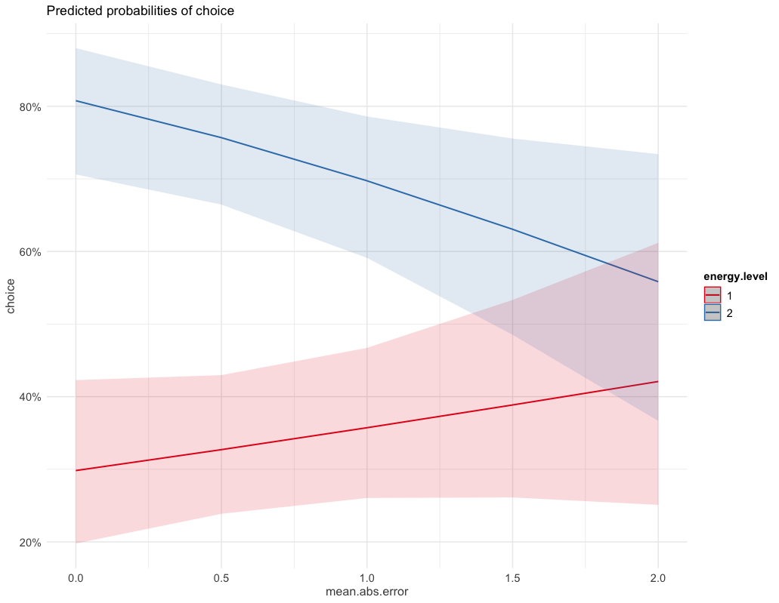

Pro-environmental choices predicted by climate change concern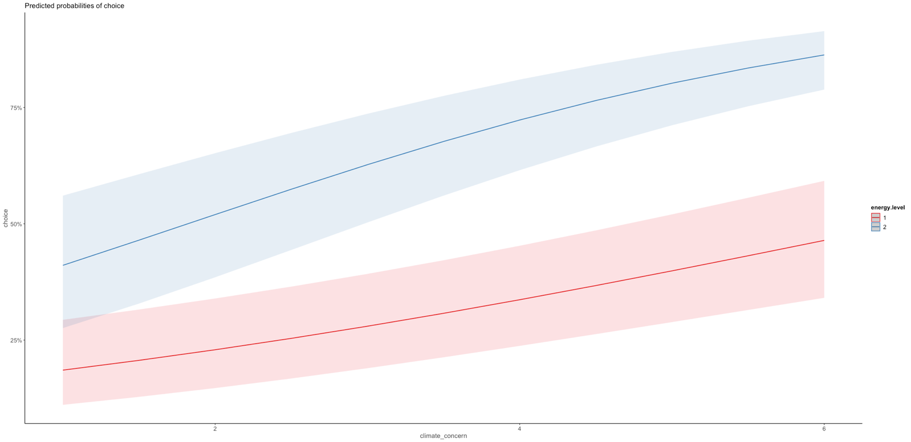

Pro-environmental choices predicted by judgment error **and** climate change concern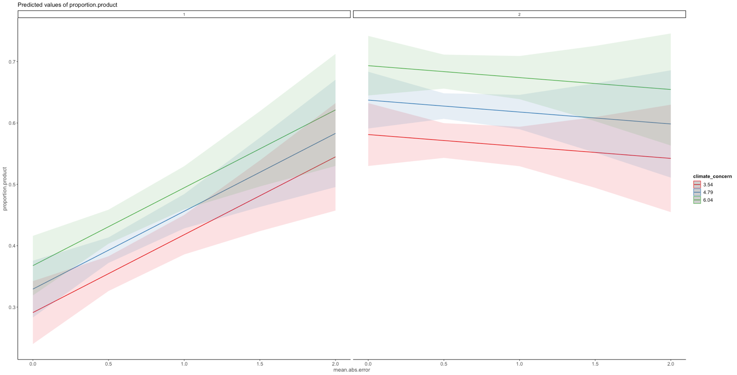

*Not complete overlap of cc concern for low energy efficiency difference (left) as timepoint in 7 years shows for policy*

Models for H1

As pre-registered:

*controlled for age, gender, country of origin and income and with random intercept*

*model.H1 <- glmer(decision~ co2 + tax + energieabhaengigkeit + zeitpunkt + gender + age + income + country + (1|id), data=data.decision, family=”binomial”)*

|  |  |  |  |
| --- | --- | --- | --- |
|  | **decision** | | |
| *Predictors* | *Odds Ratios* | *CI* | *p* |
| (Intercept) | 3.62 | 2.83 – 4.63 | **<0.001** |
| co2-30% CO2 | 1.36 | 1.27 – 1.44 | **<0.001** |
| tax [+6%] | 0.15 | 0.14 – 0.16 | **<0.001** |
| energieabhaengigkeit [+20%] | 1.19 | 1.12 – 1.26 | **<0.001** |
| zeitpunkt [in 7 Jahren] | 0.39 | 0.37 – 0.42 | **<0.001** |
| gender [male] | 0.98 | 0.84 – 1.14 | 0.824 |
| age30-39 | 0.78 | 0.61 – 1.00 | 0.054 |
| age40-49 | 0.64 | 0.50 – 0.83 | **0.001** |
| age50-59 | 0.58 | 0.45 – 0.74 | **<0.001** |
| age60-80 | 0.56 | 0.45 – 0.71 | **<0.001** |
| income [<1’500€ <3’100CHF] | 1.23 | 0.97 – 1.56 | 0.085 |
| income [> 4’000€ >5’900 CHF] | 1.14 | 0.92 – 1.40 | 0.236 |
| income [2’500- 4’000€ <4’300- 5’899CHF] | 0.97 | 0.79 – 1.20 | 0.797 |
| country [Switzerland] | 1.10 | 0.94 – 1.28 | 0.232 |
| **Random Effects** | | | |
| σ2 | 3.29 | | |
| τ00 id | 1.96 | | |
| ICC | 0.37 | | |
| N id | 1577 | | |
| Observations | 25232 | | |
| Marginal R2 / Conditional R2 | 0.184 / 0.488 | | |

Random slopes with demographics see above (stepwise non-prerigestered without error and SUm.product)

* According to contrasts with emmeans, lowest age group (18-29) versus oldest two significant differences and 30-39 age group also to both oldest age groups
* Income only lowest to third group significant everything else not, so negligible
* Political orientation: the more “right” identify, the less likely to support policies
* Trust in gov: higher trust , more likelihood to support policies

Trust and political orientation correlated by -0.098

No demographics, random slopes and random intercept

|  |  |  |  |
| --- | --- | --- | --- |
|  | **decision** | | |
| *Predictors* | *Odds Ratios* | *CI* | *p* |
| (Intercept) | 4.08 | 3.49 – 4.77 | **<0.001** |
| co2-30% CO2 | 1.70 | 1.55 – 1.87 | **<0.001** |
| tax (1% vs 6%): +6% | 0.04 | 0.04 – 0.05 | **<0.001** |
| energyindependence (10% vs 20%): +20% | 1.38 | 1.27 – 1.51 | **<0.001** |
| implementation (in 1 vs 7 years): in 7 Jahren | 0.24 | 0.20 – 0.28 | **<0.001** |
| **Random Effects** | | | |
| σ2 | 3.29 | | |
| τ00 id | 5.54 | | |
| τ00 ResponseId | 0.05 | | |
| τ11 id.co2-30% CO2 | 0.55 | | |
| τ11 id.tax+6% | 9.36 | | |
| τ11 id.energieabhaengigkeit+20% | 0.18 | | |
| τ11 id.zeitpunktin 7 Jahren | 7.79 | | |
| ρ01 id.co2-30% CO2 | -0.04 | | |
| ρ01 id.tax+6% | -0.27 | | |
| ρ01 id.energieabhaengigkeit+20% | -0.09 | | |
| ρ01 id.zeitpunktin 7 Jahren | -0.35 | | |
| ICC | 0.73 | | |
| N id | 1628 | | |
| N ResponseId | 1628 | | |
| Observations | 26048 | | |
| Marginal R2 / Conditional R2 | 0.201 / 0.784 | | |

Models for H1b

With demographics

|  |  |  |  |
| --- | --- | --- | --- |
|  | **decision** | | |
| *Predictors* | *Odds Ratios* | *CI* | *p* |
| (Intercept) | 7.66 | 5.22 – 11.26 | **<0.001** |
| co2-30% CO2 | 1.69 | 1.54 – 1.85 | **<0.001** |
| tax (1% vs 6%): +6% | 0.04 | 0.04 – 0.05 | **<0.001** |
| energyindependence (10% vs 20%): +20% | 1.38 | 1.27 – 1.51 | **<0.001** |
| implementation (in 1 vs 7 years): in 7 Jahren | 0.24 | 0.21 – 0.28 | **<0.001** |
| concern.scaled | 2.19 | 1.96 – 2.45 | **<0.001** |
| income<1'500- 2'499€ 3'100-4'299CHF | 0.81 | 0.59 – 1.12 | 0.211 |
| income: 2'500- 4'000€ <4'300- 5'899CHF | 0.68 | 0.50 – 0.94 | **0.018** |
| income: > 4'000€ >5'900 CHF | 0.82 | 0.60 – 1.13 | 0.225 |
| gender: female | 0.96 | 0.78 – 1.18 | 0.673 |
| age30-39 | 0.85 | 0.60 – 1.19 | 0.338 |
| age40-49 | 0.66 | 0.47 – 0.93 | **0.018** |
| age50-59 | 0.55 | 0.39 – 0.77 | **<0.001** |
| age60-80 | 0.44 | 0.32 – 0.61 | **<0.001** |
| country: Switzerland | 1.14 | 0.92 – 1.40 | 0.229 |
| politicalorientation.scaled | 0.86 | 0.77 – 0.96 | **0.009** |
| trust.gov.scaled | 1.35 | 1.23 – 1.48 | **<0.001** |
| zeitpunktin 7 Jahren:concern.scaled | 0.45 | 0.40 – 0.52 | **<0.001** |
| **Random Effects** | | | |
| σ2 | 3.29 | | |
| τ00 id | 5.35 | | |
| τ11 id.co2-30% CO2 | 0.61 | | |
| τ11 id.tax+6% | 9.72 | | |
| τ11 id.energieabhaengigkeit+20% | 0.20 | | |
| τ11 id.zeitpunktin 7 Jahren | 6.71 | | |
| ρ01 | -0.28 | | |
|  | -0.36 | | |
|  | -0.27 | | |
|  | -0.25 | | |
| ICC | 0.71 | | |
| N id | 1628 | | |
| Observations | 26048 | | |
| Marginal R2 / Conditional R2 | 0.258 / 0.787 | | |

**Models for H3a**

|  |  |  |  |
| --- | --- | --- | --- |
|  | **mean absolute error** | | |
| *Predictors* | *Estimates* | *CI* | *p* |
| (Intercept) | 0.74 | 0.66 – 0.82 | **<0.001** |
| gender: male | -0.04 | -0.06 – -0.01 | **0.005** |
| age30-39 | 0.01 | -0.03 – 0.06 | 0.566 |
| age40-49 | -0.02 | -0.06 – 0.02 | 0.338 |
| age50-59 | -0.04 | -0.09 – -0.00 | **0.036** |
| age60-80 | -0.05 | -0.09 – -0.01 | **0.015** |
| country: Switzerland | 0.02 | -0.01 – 0.04 | 0.158 |
| income<1'500- 2'499€ 3'100-4'299CHF | -0.02 | -0.06 – 0.02 | 0.248 |
| income: 2'500- 4'000€ <4'300- 5'899CHF | -0.08 | -0.12 – -0.04 | **<0.001** |
| income: > 4'000€ >5'900 CHF | -0.07 | -0.11 – -0.03 | **<0.001** |
| climate_concern | -0.01 | -0.02 – -0.00 | **0.029** |
| mean frequency device use | 0.03 | 0.01 – 0.06 | **0.018** |
| Observations | 1139 | | |
| R2 / R2 adjusted | 0.052 / 0.043 | | |

What predicts accuracy?

|  |  |  |  |
| --- | --- | --- | --- |
|  | **mean absolute error** | | |
| *Predictors* | *Estimates* | *CI* | *p* |
| (Intercept) | 0.76 | 0.64 – 0.89 | **<0.001** |
| gender: male | -0.04 | -0.06 – -0.01 | **0.005** |
| age30-39 | 0.01 | -0.03 – 0.06 | 0.550 |
| age40-49 | -0.02 | -0.06 – 0.02 | 0.318 |
| age50-59 | -0.05 | -0.09 – -0.01 | **0.020** |
| age60-80 | -0.05 | -0.09 – -0.01 | **0.014** |
| income<1'500- 2'499€ 3'100-4'299CHF | -0.02 | -0.07 – 0.02 | 0.226 |
| income: 2'500- 4'000€ <4'300- 5'899CHF | -0.07 | -0.11 – -0.03 | **<0.001** |
| income: > 4'000€ >5'900 CHF | -0.06 | -0.10 – -0.02 | **0.006** |
| country: Switzerland | 0.02 | -0.01 – 0.04 | 0.179 |
| education: obligatory school | -0.00 | -0.05 – 0.04 | 0.828 |
| education: middle school | -0.03 | -0.08 – 0.02 | 0.215 |
| education: degree | -0.06 | -0.10 – -0.01 | **0.012** |
| climate_concern | -0.01 | -0.02 – 0.00 | 0.085 |
| emotions.crisis.neg.tot | -0.00 | -0.02 – 0.01 | 0.626 |
| mean frequency device use | 0.03 | 0.01 – 0.06 | **0.019** |
| V2 | 0.00 | -0.06 – 0.07 | 0.935 |
| Observations | 1139 | | |
| R2 / R2 adjusted | 0.063 / 0.049 | | |

|  |  |  |  |
| --- | --- | --- | --- |
|  | **mean.est.bias** | | |
| *Predictors* | *Estimates* | *CI* | *p* |
| (Intercept) | -0.24 | -0.54 – 0.05 | 0.109 |
| gender: male | -0.07 | -0.13 – -0.01 | **0.032** |
| age30-39 | -0.06 | -0.17 – 0.04 | 0.250 |
| age40-49 | 0.02 | -0.09 – 0.12 | 0.768 |
| age50-59 | 0.04 | -0.07 – 0.14 | 0.485 |
| age60-80 | -0.01 | -0.11 – 0.09 | 0.865 |
| income<1'500- 2'499€ 3'100-4'299CHF | 0.09 | -0.01 – 0.19 | 0.067 |
| income: 2'500- 4'000€ <4'300- 5'899CHF | 0.13 | 0.03 – 0.23 | **0.008** |
| income: > 4'000€ >5'900 CHF | 0.17 | 0.07 – 0.27 | **0.001** |
| country: Switzerland | 0.19 | 0.13 – 0.25 | **<0.001** |
| education.fmiddle school | -0.02 | -0.11 – 0.06 | 0.567 |
| education.fno formal education | -0.06 | -0.17 – 0.05 | 0.301 |
| education.fobligatory school | -0.08 | -0.16 – -0.00 | **0.040** |
| climate_concern | 0.05 | 0.03 – 0.08 | **<0.001** |
| emotions.crisis.neg.tot | 0.01 | -0.03 – 0.04 | 0.726 |
| mean frequency device use | -0.05 | -0.11 – 0.01 | 0.121 |
| V2 | -0.11 | -0.28 – 0.05 | 0.166 |
| Observations | 1139 | | |
| R2 / R2 adjusted | 0.076 / 0.063 | | |